Abbildungsverzeichnis
Kunstbeispiele
01 |  |  | 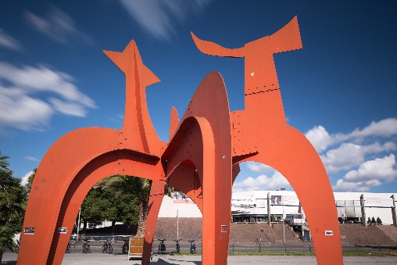 | https://de.wikipedia.org/wiki/Datei:Sculpture_Hellebardier_Alexander_Calder_Nordufer_Hanover_Germany_03b.jpg  Alexander Calder * 1898 in Lawnton, USA
02 | 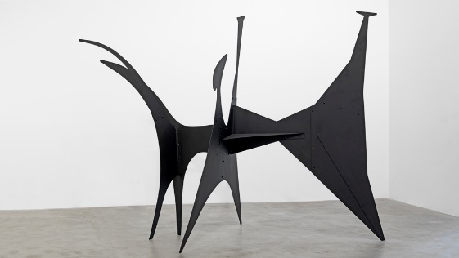 |  |  | https://robbreport.com/shelter/art-collectibles/two-titans-of-20th-century-art-get-their-due-2826749/  Alexander Calder * 1898 in Lawnton, USA
03 |  |  |  | https://www.pinterest.de/pin/308496643208595837/  William Kentridge, *1955 Johannesburg, Südafrika
04 |  |  |  | https://images.derstandard.at/img/2017/01/03/Kentridge-9.jpg?w=1600&s=7df98214  William Kentridge, *1955 Johannesburg, Südafrika
05 |  |  | 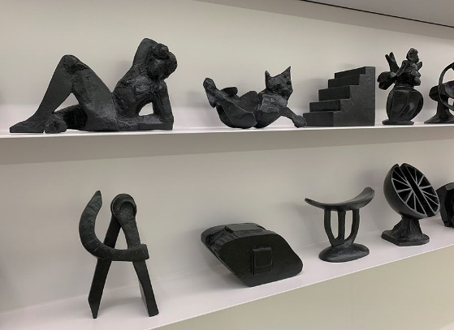 | kentridge_KMBasel2019 (artfritz.ch)  William Kentridge, *1955 Johannesburg, Südafrika
06 |  |  |  | https://www.pinterest.ch/pin/436778863852119154/  Sue Webster *1967 in Leicester, UK und Tim Noble * 1966 in Stroud, UK
07 |  |  | 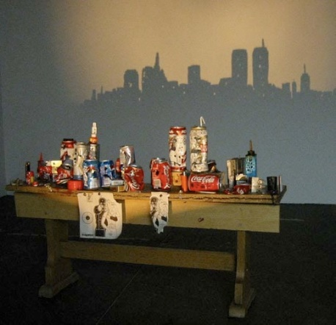 | https://wasteresearchng.wordpress.com/2013/05/06/artists-tim-noble-and-sue-webster/  Sue Webster *1967 in Leicester, UK und Tim Noble * 1966 in Stroud, UK
08 |  |  |  | https://www.pinterest.de/pin/307863324532242828/  Vincent Bal, *1971 in Gent, Niederlande
09 |  |  | 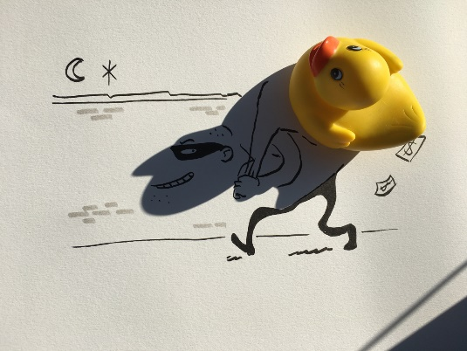 | https://ze.tt/ein-kuenstler-verwandelt-alltaegliche-schatten-in-witzige-cartoons-bildergalerie-instagram/  Vincent Bal, *1971 in Gent, Niederlande

